Name: Mrunali Katta

ID: 017516785

**DATA 226 Homework 03**

1. (+1) Create database DEV and schema ANALYTICS

-- to create a database

CREATE DATABASE DEV;

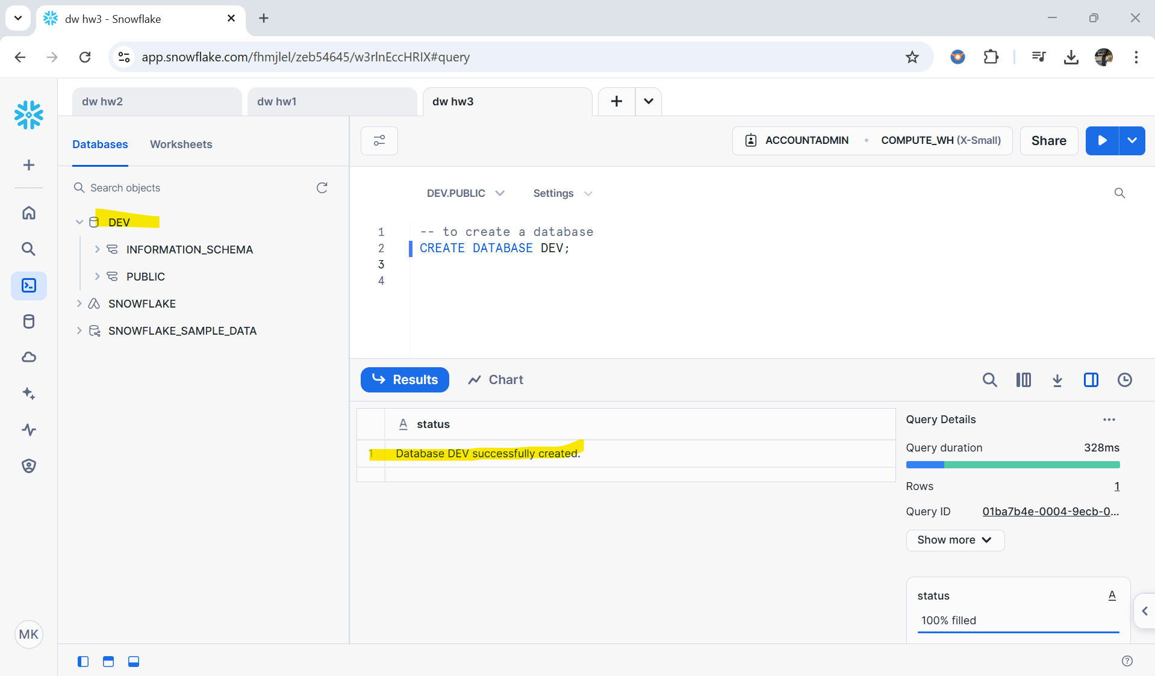

-- to create a schema

CREATE SCHEMA ANALYTICS;

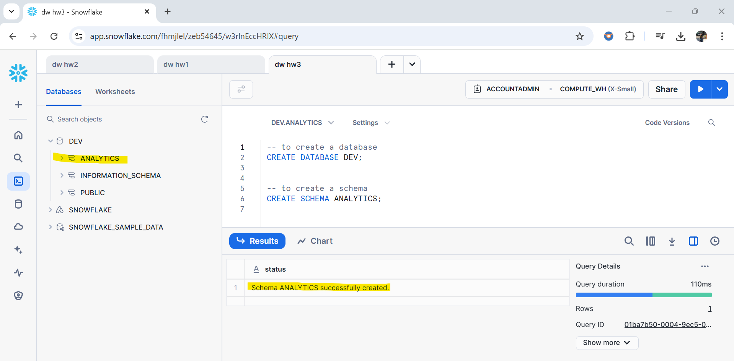

2. (+2) Create a Table PROD_HST_TBL

--create PROD_HST_TBL table

CREATE TABLE PROD_HST_TBL (

RECORD_ID NUMBER(38,0),

YEAR NUMBER(38,0),

MONTH NUMBER(38,0),

DAY NUMBER(38,0),

STORE_ID NUMBER(38,0),

SKU_ID NUMBER(38,0),

TOTAL_PRICE NUMBER(38,4),

BASE_PRICE NUMBER(38,4),

UNITS_SOLD NUMBER(38,0)

);

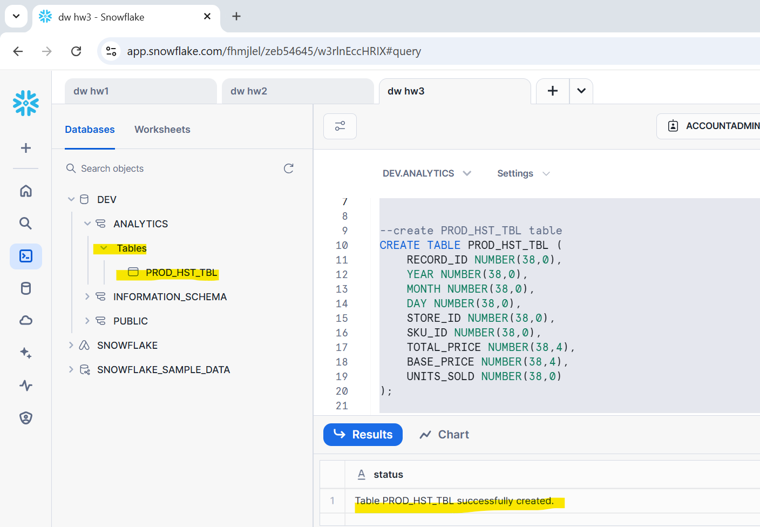

3. (+3) Create a view to forecast SKU ‘219029’ of STORE ‘9490’

-- view creation script uses a CTE

-- Create a view to forecast SKU '219029' from STORE '9490'

CREATE VIEW BOOKS_ST_VW

AS

WITH feature_engineering AS (

SELECT

TO_TIMESTAMP_NTZ(TO_DATE(YEAR || '-' || MONTH || '-' || DAY)) AS SALE_TS, UNITS_SOLD

FROM prod_hst_tbl

WHERE SKU_ID=219029 AND STORE_ID=9490

)

SELECT SALE_TS, UNITS_SOLD FROM feature_engineering

GROUP BY SALE_TS, UNITS_SOLD

ORDER BY SALE_TS;

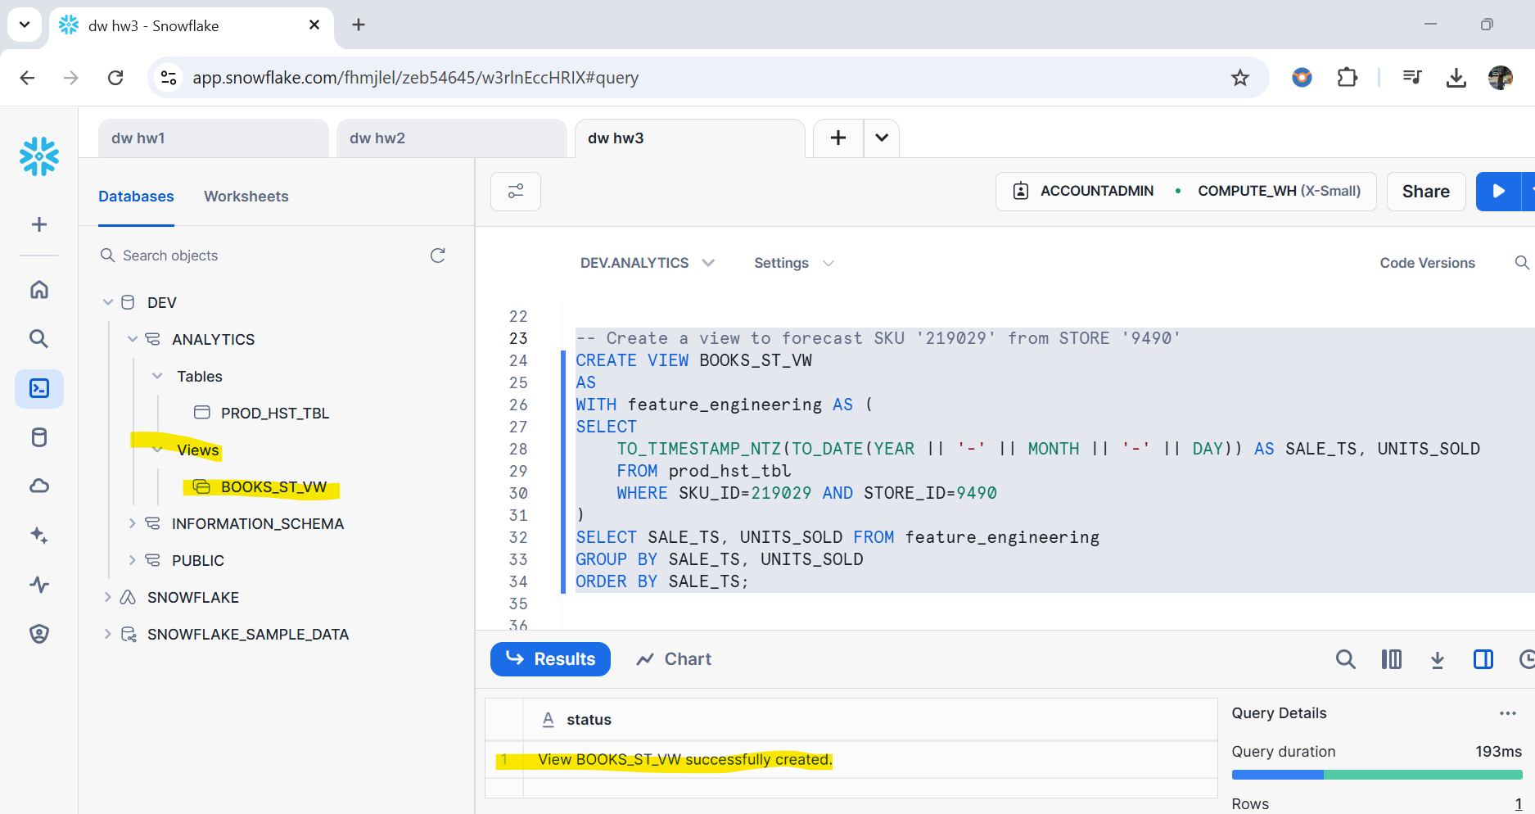

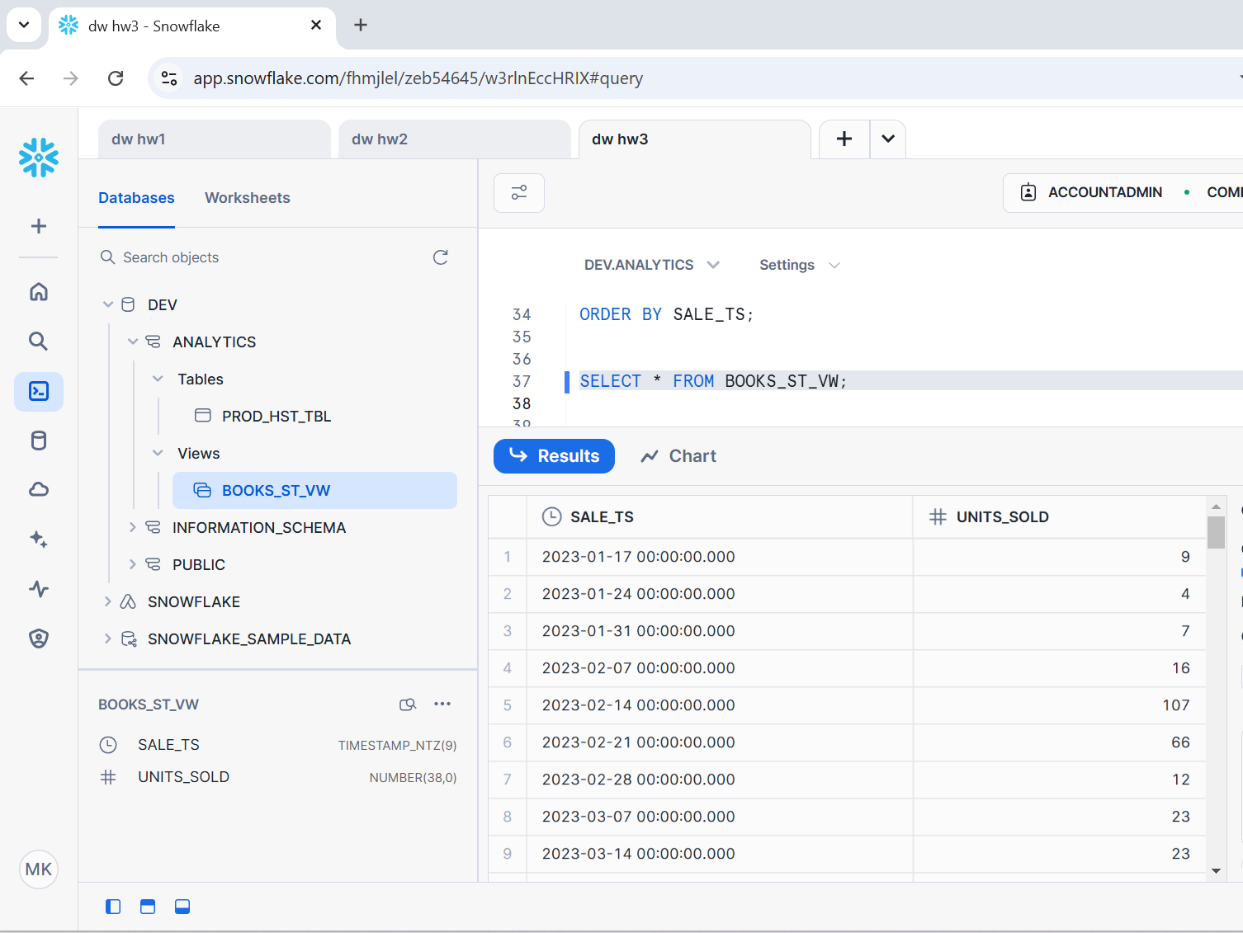

4. (+3) Create a forecast model ‘books_mdl’

--to create a forecast model ‘books_mdl’

CREATE SNOWFLAKE.ML.FORECAST books_mdl(

INPUT_DATA => TABLE(BOOKS_ST_VW),

TIMESTAMP_COLNAME => 'SALE_TS',

TARGET_COLNAME => 'UNITS_SOLD',

CONFIG_OBJECT => {'ON_ERROR' : 'SKIP'}

);

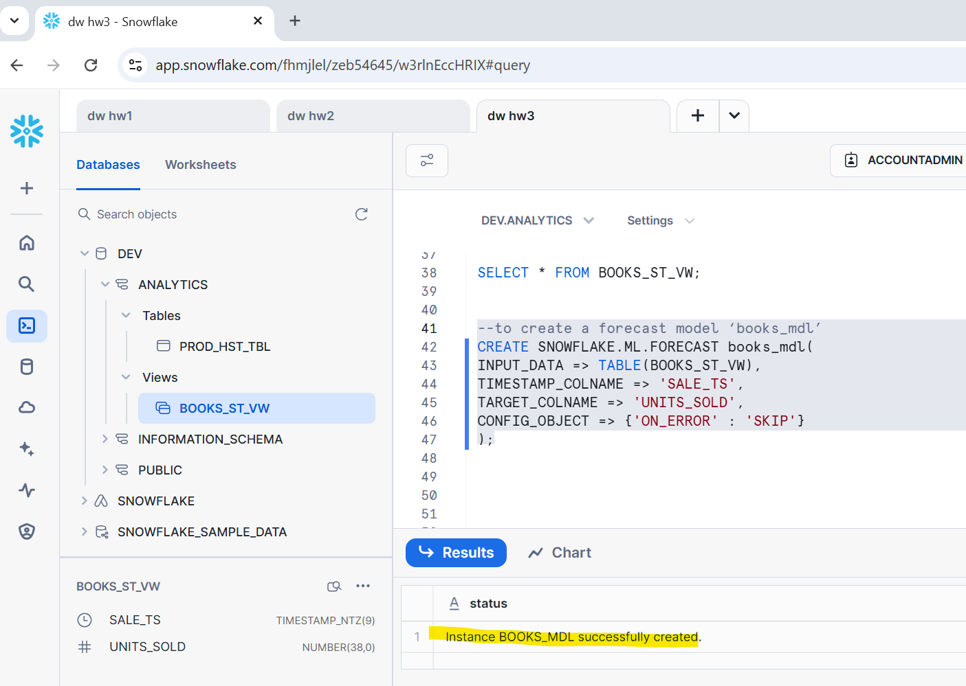

5. (+1) Display the Results to predict next 4 weeks.

CALL books_mdl!FORECAST(FORECASTING_PERIODS => 4);

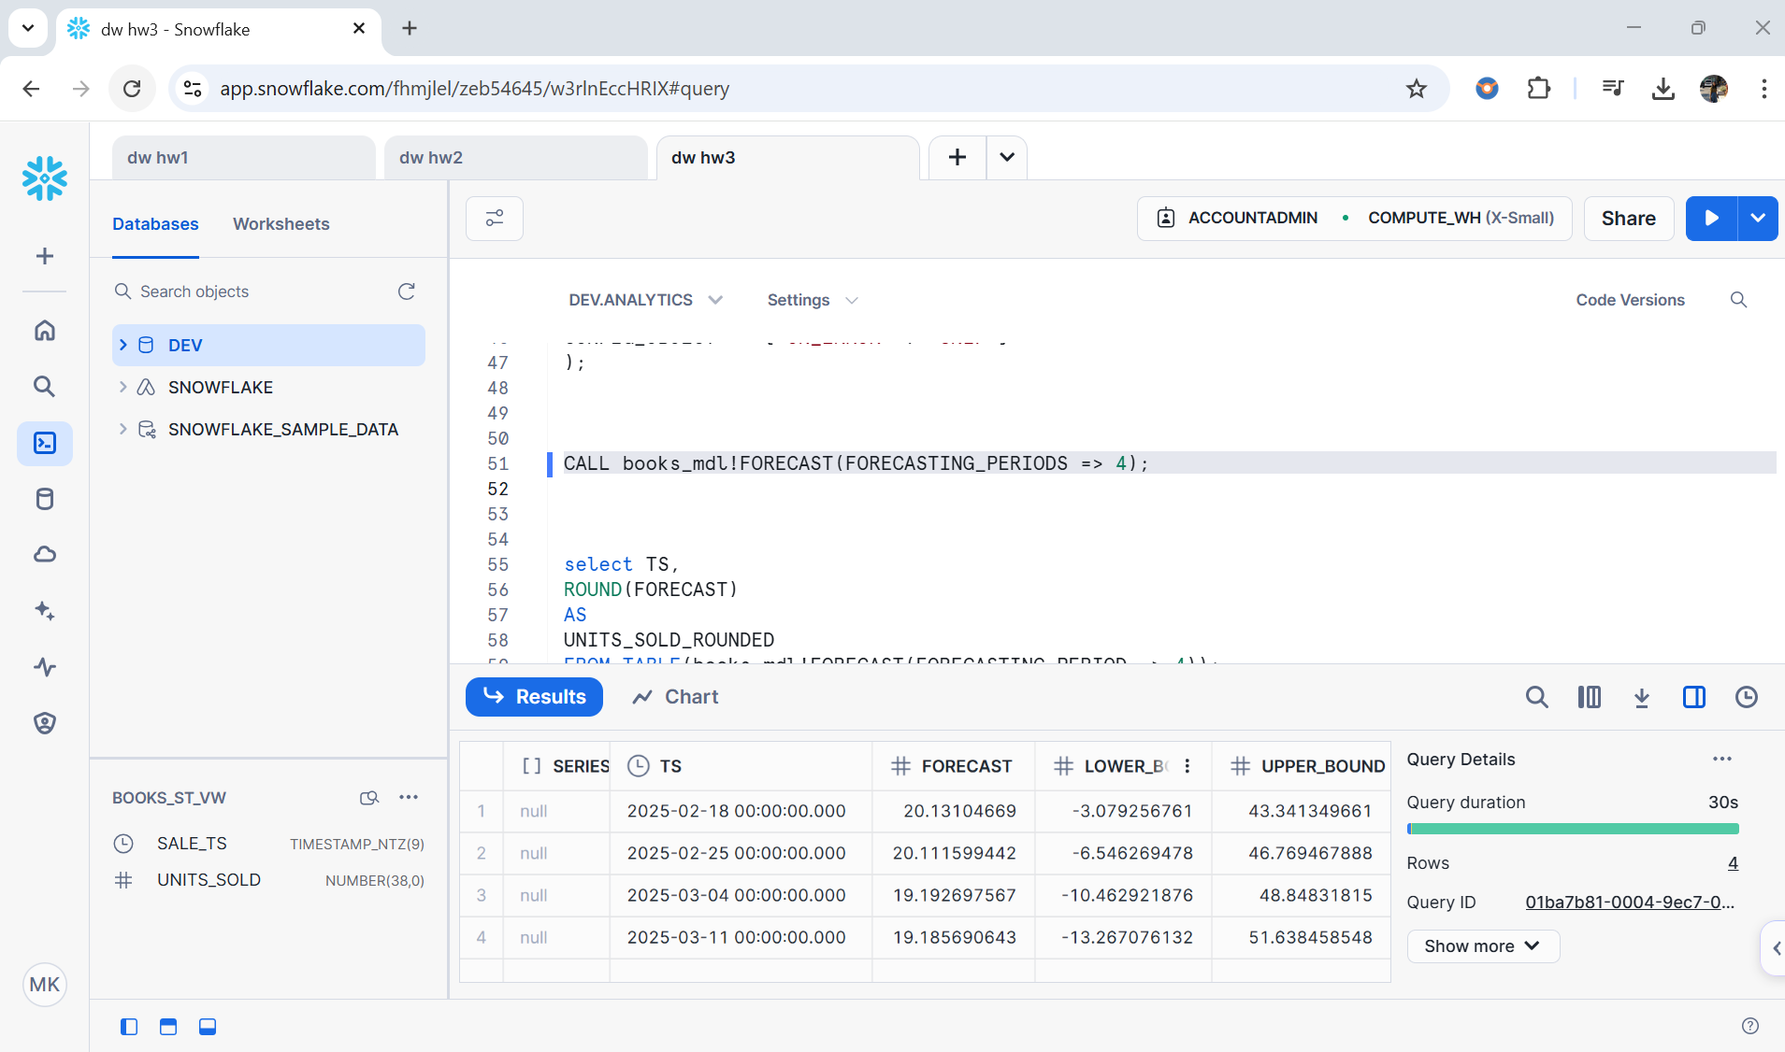

-- ROUNDED THE VALUE

SELECT TS ,

ROUND(FORECAST) AS UNITS_SOLD_ROUNDED

FROM TABLE(books_mdl!FORECAST(FORECASTING_PERIODS => 4));

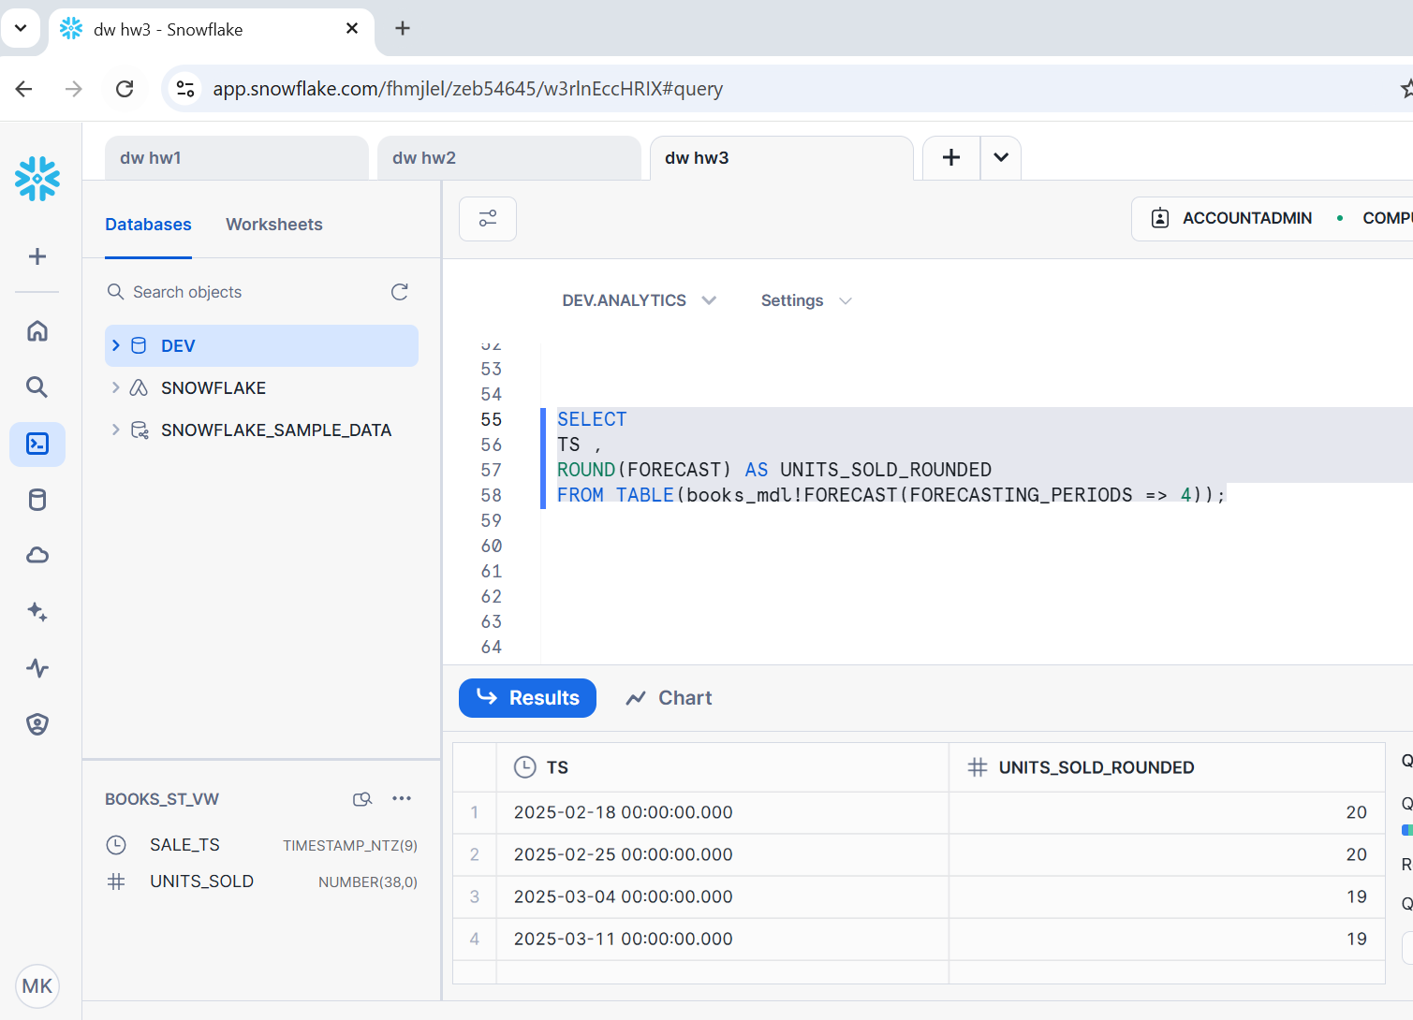

6. (+3) Explain your understanding about the Forecasting Process.

→ What is forecasting?

Forecasting is a method which makes informed predictions by using historical data as the main input for determining the course of future trends. Usually, companies use forecasting for many different purposes, such as predicting future expenses and determining how to allocate their budget etc.

Below is a detailed explanation of the forecasting:

1. **Creating a Database and Schema**: First we are creating a **DEV** database and an **ANALYTICS** schema in Snowflake for query efficiency.
2. **Creating a table for Historical Data**: Then created a table named **PROD_HST_TBL** to store daily sales transactions like the year, month, day, store id (SKU IDs) , units sold, total_price and base_price. To retrieve data to analyze patterns.
3. **Creating a View**: After table creation we have created a **BOOKS_ST_VW** view, using query to filter results based on SKU with ID = ‘219029’ and STORE with ID= ‘9490’. The basically here filters data and then converts date fields into a timestamp (SALE_TS), and aggregates units sold by timestamp.
4. **Creating a Forecast Model**: Then created a forecast model called **‘books_mdl’** to predict future sales based on patterns. Here we have used Snowflake’s built-in ML.FORECAST model to train using the BOOKS_ST_VW where the model uses SALE_TS (timestamp) as the time and UNITS_SOLD as the target variable
5. **Forecasting:** The model predicts sales for 4 future weeks. Lastly the **ROUND()** function is used to round off the results are integers.
6. **Final Result :** The final result of forecasting displays a uniform sales of 20 units for the first two weeks,. Then it drops to 19 in 3rd and 4th week. This tells that a stable demand initially with a light dip following weeks which might be because of price hikes, poor product quality, low demand etc reasons.